Exercise

Instructions: Create a folder in your desktop with your registration number (Eg: ”IT.......”). You need to save the R script file and take screenshots of the command prompt with answers and save it in a word document inside the folder. Save both R script file and word document with your registration number (Eg: ”IT........”). After you finish the exercise, zip the folder and upload the zip file to the submission link.

1. A vending machine owner claims that customers choose the four snack types (A, B, C, D) with equal probability. To test this claim, a researcher records the number of purchases for each snack type during one week and results are given below

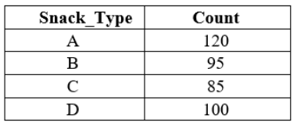

1. State the null and alternative hypotheses for the test.

**Null and Alternative Hypotheses**

* **Null Hypothesis (H0):** Customers choose the four snack types (A, B, C, D) with equal probability. This means the probability of choosing any snack is the same (PA= PB= PC = PD= 0.25).
* **Alternative Hypothesis (H1):** The probabilities of choosing the four snack types are not all equal. At least one snack type's probability is different from the others.

1. Perform a suitable chi-squared test to test the null hypothesis.

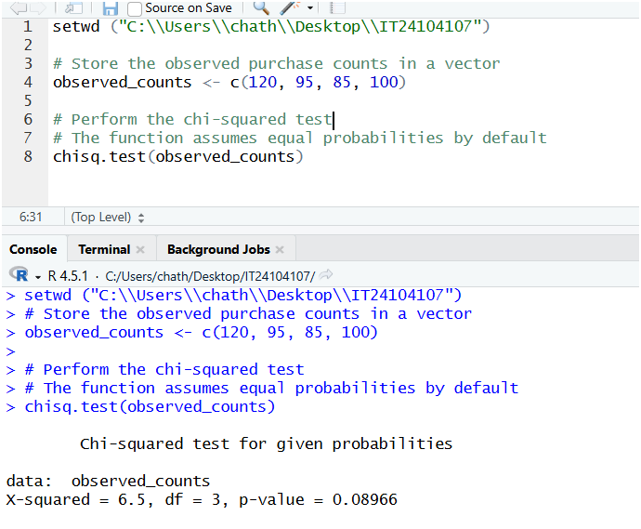

1. Give your conclusions based on the results.

**Conclusion**

To make a conclusion, we compare the **p-value** from the test output to a significance level, which is typically $\alpha = 0.05$.

* The p-value is **0.08969**.
* The significance level is **0.05**.

Since the **p-value (0.08969) is greater than the significance level (0.05)**, we **fail to reject the null hypothesis**.